Swim Safe schools programme

Information Pack

What is Swim Safe?

Children love swimming outdoors, but swimming in the sea, rivers and lakes is different to swimming in a pool where most swimming lessons take place.

As a result Swim England, the national governing body for swimming in England, and the RNLI, the charity that saves lives at sea, created the Swim Safe programme

Swim Safe offers free outdoor swimming and water safety sessions for children aged between 7 and 14. Children learn how to keep safe when swimming outdoors and know what to do if they get into trouble. Swim Safe runs every summer at beach, lake and other inland outdoors water locations across the UK.

The Swim Safe schools programme offers free to access, practical water safety sessions, using qualified teachers and open water lifeguards at outdoor water locations around the United Kingdom. The 45 minute sessions are tailored specifically to meet the following elements of Key stage 2:

- Perform safe self-rescue in different water-based situations.
- Take part in outdoor and adventurous activity challenges both individually and within a team.

All pupils will also receive some safety messaging items to take away after the session.

Aimed at pupils who are already able to swim 25 metres unaided, the Swim Safe schools programme builds on that ability and teaches them the essential techniques to enable them to be safe in and around open water (shore and shallow water adaptations are available for weaker swimmers on request).

We look forward to welcoming you and your school to the Swim Safe schools programme.

What to bring on the session
Pupils will need to bring;
- A swimming costume (preferably already on under clothes)
- A towel
- Old trainers to wear up to the waters edge
- Sun cream and sun hat if applicable (Sun cream should be applied and thoroughly rubbed in at least 30 minutes before entering the water)
- Any medication
- Warm clothing for after the session (within school guidelines)
- A bottle of water
- Snack for after the session
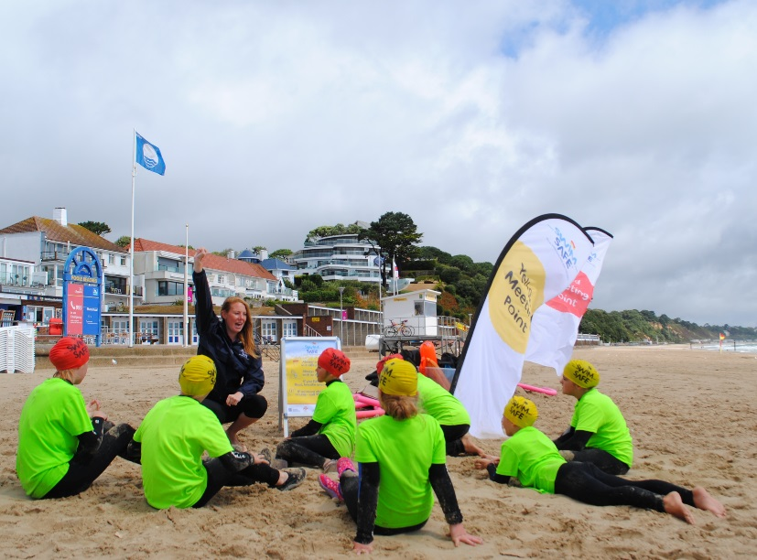
A full length wetsuit will be provided for each pupil along with swim caps and fluorescent rash vests.

Teachers will need to bring:
- Any medication for yourselves/pupils
- Adequate staff to assist with children on dry land and any children with additional needs. We suggest one adult per ten pupils to assist with getting into wetsuits. Should any adult/teacher need to get in water with any children with additional needs, long legged/sleeved wetsuits are recommended and need to be provided by the school.

The consent form found in this pack should be given to all parents of participating children. This needs to be signed and returned to the school before a child can take part in the Swim Safe schools programme.

If there are any serious medical issues for any children these must be raised before the session begins.

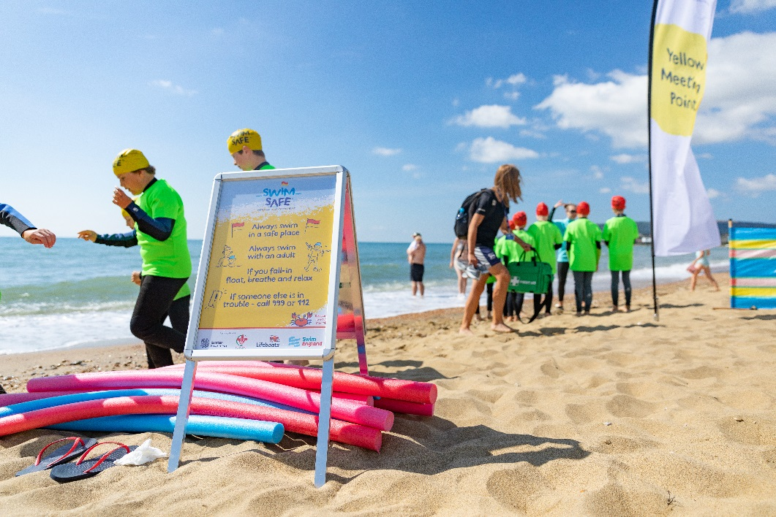

Site Specific Information

Site Name | Walton on Naze
Site address | Hipkins Beach
Site coordinator | Joanne Zachwatajlo / Richard Sands  jzachwatajlo@tendringdc.gov.uk  01255 686750
Changing facilities | Male/Female Changing Facilities  Toilets
Access to site | Parking available for mini busses/coaches  Walking routes
Max number of children per session | 24 Children per session
Other | Aa picnic area so that schools can bring packed lunches for after the session.  Can schools take part in any other activity at the site on the same day? - TBC

Swim Safe schools programme consent form

Swim England, the national governing body for swimming in England, and the RNLI, the charity that saves lives at sea, are continuing to work together for the sixth time this summer on Swim Safe, a swimming and beach/lake safety awareness initiative for children.
Each session is FREE to access and includes in-water safety tuition with trained, qualified teachers and open water lifeguards.
All children will be provided with a full length wetsuit, a latex swim hat and a fluorescent rash vest to wear in the water.
The venue has been risked assessed and all staff are appropriately DBS checked and qualified.
---------------------------------------------------------------------------------------------------------------------------
Childs name _____________________________________________________________
Childs swimming ability (please delete as appropriate) – My child can / can’t swim 25m.
Childs medical conditions or additional requirements __________________________________________________________________________________________________________________________________________________
By signing the below you as a parent / guardian are agreeing to the following:
- You have accurately detailed your child’s swimming ability
- Your child will be taking part in a session that lasts approximately 45 minutes. The session will include both in and out of water safety messaging.
- You accept that due to changes in the weather, the session may be cancelled at any time and the site will endeavour to inform the school of this situation as soon as possible on the day and re-arrange where possible.
Swim England and the RNLI may take photographs and record sessions in which your child participates. Images may be displayed on the RNLI and Swim England website, and used for purposes of education and training and promotion of future campaigns. We will follow good practice on photography as contained in Wavepower, (Swim England’s child safeguarding policy and procedures; http://www.swimming.org/asa/library/document/wavepower-2009-11-section-2 pages 84-85).
If you do not wish for your child to be photographed please tick the box 

Signed: ____________________________ Parent/Guardian (please select)
Parent / Guardian (PRINT NAME) _____________________________
Date____________
Swim Safe FAQs
- Who can we contact on the day of the programme?
Please contact your local site coordinator on the day of the programme. They should be in contact before the session to confirm details with you and provide contact details.

- Children in the class are of different swimming ability, how will they be catered for?
The consent form has asked parents how water confident pupils are. Children will be grouped and have activities appropriate to their ability.

- Can the children take part again in the public sessions?
Yes the children can take part as many times as they like in the public sessions. To book on to a public session, their parents will need to visit www.swimsafe.org.uk

- How long will the Swim Safe schools programme session run?
Sessions of 1 hour will include changing, water safety messages, in water tuition in small groups. We ask you to arrive 15 - 30 minutes before your session start time to make sure all the children have time to get kitted out.

- Will the sessions still run in bad weather?
Each day a risk assessment will take place of the weather and the site and a decision will be made by the site coordinator if it is safe for the sessions to take place. The nominated teacher will be called if any cancellations need to be made.

- Do children receive anything for taking part?
Yes each child will receive a Swim Safe swimming cap, and a t-shirt, a badge and a safety message keyring.
- How can I leave feedback on the programme?
Feedback can be given at site to the site coordinator. However, if you feel you want to feedback after the event then please send this through to swimsafe@swimming.org

- Will a first aid kit be available at the Swim Safe site or do teachers need to bring one?
Each site will be equipped with basic first aid and have contact details as part of their risk assessment to get help in an emergency. If any child needs particular items we would ask the school to bring them

- Will school teachers be expected to get in the water with the children?
There will be 1 instructor to 8 children and a lifeguard to supervise the session. School teachers will not be expected to enter the water except if they have a pupil with additional needs that may require them to do so. Any school teacher entering the water will need to provide their own wetsuit

- What will school teachers be doing while the Swim Safe session is going on?
School teachers will need to assist pupils with wetsuits and we would welcome their participation in the shore activities

